**Karan Arora**  **R.L. Institute M: 9416974837**

**Max Time : 1 ½ hr** **Class = 12th Biology Test**  **Max Marks : 40**

**BIOLOGY & HUMAN WELFARE**

1. Multiple choice questions : [ 1 X 10 = 10]
2. Biogas is produced by __________ breakdown of biomass with the help of _________ bacteria.

|  |  |
| --- | --- |
| a) anaerobic ; Methanococcus | b) Aerobic ; rhizobium |
| c) anaerobic , rhizobium | d) aerobic ; Methanobacterium |

1. During life cycle of plasmodium, sexual reproduction takes place in which of the following hosts?

|  |  |  |  |
| --- | --- | --- | --- |
| a) Human | b) female anopheles | c) male anopheles | d) Both (a) & (b) |

1. Transplantation of tissue/organs to save certain patients often fails due to rejection of such tissues/organs by the patient. Which type of immune response is responsible for such rejection?

|  |  |  |  |
| --- | --- | --- | --- |
| a) Auto immune response | b) Humoral immune system | c) Physiological immune | d) cell mediated immune |

1. Which of the following alcoholic drinks is produced without distillation?

|  |  |  |  |
| --- | --- | --- | --- |
| a) Wine | b) Whiskey | c) Rum | d) brandy |

1. The primary treatment of waste water involves the removal of :

|  |  |  |  |
| --- | --- | --- | --- |
| a) dissolved impurities | b) stable particles | c) toxic substances | d) harmful bacteria |

1. The substance given to cancer patient in order to activate their immune system and destroy the tumor is :

|  |  |  |  |
| --- | --- | --- | --- |
| a) Histamine | b) interleukin | c) $α$-interferon | d) morphine |

1. Match column I and column II

|  |  |
| --- | --- |
| Column I | Column II |
| A. Ganga action plan | I. N­2 fixing cyanobacterium |
| B. Bt-cotton | II. Ministry of environment & forest |
| C. Rhizobium | III. Insect resistant plant |
| D. Nostoc | IV. N­2 fixing bacterium |

|  |  |
| --- | --- |
| a) A – II ; B – III ; C – IV ; D – I | b) A – III ; B – II ; C – IV ; D – I |
| c) A – II ; B – IV ; C – III ; D – I | d) A – I ; B – III ; C – II ; D – IV |

1. LSD obtained from :

|  |  |  |  |
| --- | --- | --- | --- |
| a) Erythroxylum coca | b) cannabis sativa | c) Claviceps purpurea | d) papaver somniferum |

1. Increased asthmatic attacks in certain seasons are related to :

|  |  |
| --- | --- |
| a) eating fruits preserved in tin containers | b) inhalation of seasonal pollen |
| c) low temperature | d) hot and humid environment |

1. The free living fungus Tricoderma can be used for :

|  |  |
| --- | --- |
| a) insects | b) Biological control of plant diseases |
| c) controlling butterfly caterpillars | d) producing antibiotics |

1. A student on a school trip started sneezing and wheezing soon after reaching the hill station for no reasons. But, on return to the plains, the symptoms disappeared. What is such a response called? How does the body produced it? [ 2 ]
2. State the role of thymus as a lymphoid organ. Name the cells that are released from it and mention their function.

[ 2 ]

1. Mention one application of : (a) passive immunization (b) Cytokinin barrier [ 2 ]
2. Explain the significant role of genus ‘Nucleopolyhedrovirus’ in an ecological sensitive area. [ 2 ]
3. Name the microbe help in production of following products commercially : [ 2 ]

(i) Statin (ii) citric acid (iii) Penicillin (iv) Butyric acid

1. (i) Name the virus that cause cancer in humans. [ 3 ]

(ii) How do benign tumors turn malignant? How does the latter harm the human body?

1. Identify A, B and C in the diagram of an antibody given above and answer the questions : [ 3 ]

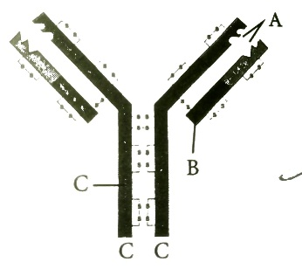

(a) Write the chemical nature of an antibody.

(b) Name the cells that produced antibodies in humans.

(c) Mention the type of immune response provided by an antibody.

1. What are the harmful effects of chemical pesticides? And what are the advantages of using biofertilisers in agriculture? [ 3 ]
2. BOD is measure of organic matter present in water. The data below shows the concentration of BOD in different samples obtained from the primary effluent , secondary effluent , untreated sewage and river water. [ 3 ]

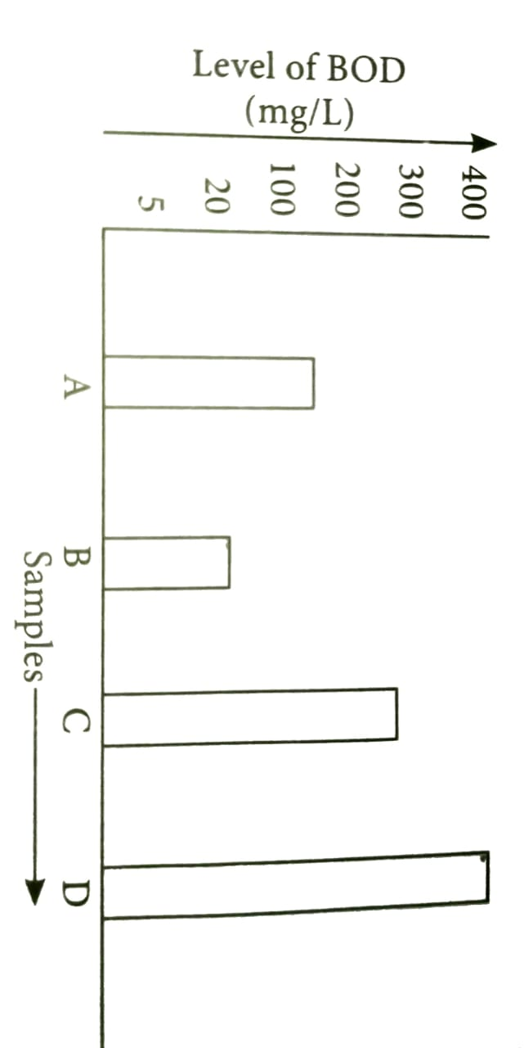

(a) With reference to the above graph, identify the source of different samples A , B , C , D.

(b) What would happen if D is disposed off in B directly?

(c) Which among the given samples will contain large number of pathogenic microbes?

1. (i) Name the causative organism for following diseases : [ 4 ]

(a) Elephantiasis (b) ring worm (c) Amoebiasis

(ii) How can public hygiene help to control infectious diseases?

1. (a) Write the source and the effect on the human body of the following drugs. [ 4 ]

(i) Morphine (ii) Cocaine (iii) Marijuana

(b) How does smoking tobacco in human leads to oxygen deficiency in their body?